  - EPAM CoE • Team LNCT Qubit

MODULE 07
Compiler and CPU Reordering
Assigned owner: Vanshraj Singh Rathore
Hardware Concurrency, Memory Models & Lock-Free Design
Evidence status: source-backed study and test design prepared; local build and experiments NOT RUN.
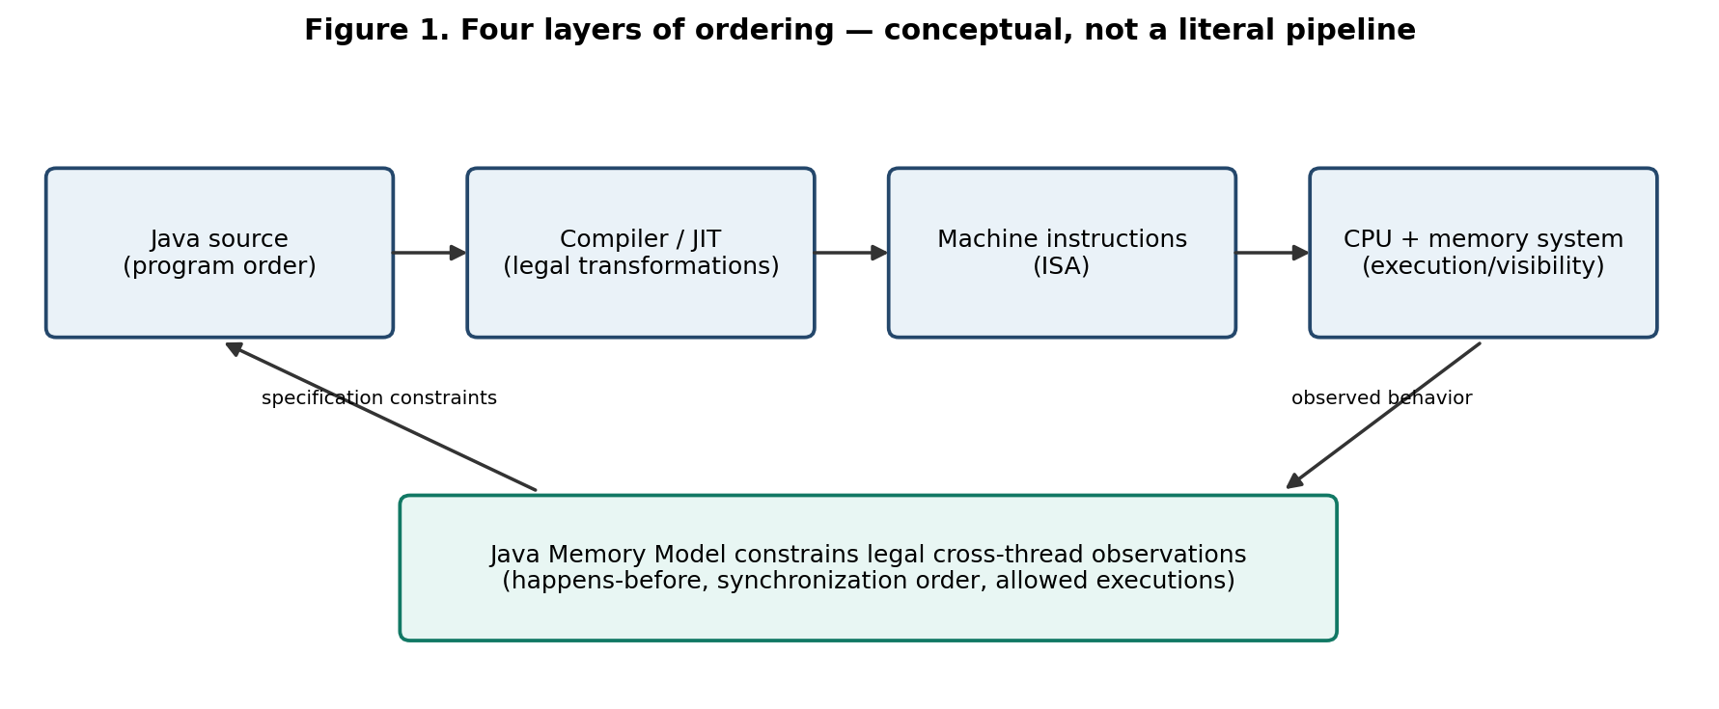
Prepared as a focused engineering module. Results remain pending until executed on the team's target machine.

Executive summary
Reordering is not one single phenomenon. Java source order, compiler/JIT transformations, CPU execution, and the order in which other threads can observe memory operations are different concepts. The Java Memory Model (JMM) defines which outcomes a Java program may exhibit; it does not require every source statement to map to one machine instruction or every processor to implement ordering identically.
This module studies two standard litmus patterns: store buffering and message passing. Each is shown with plain fields and with a volatile synchronization edge. The report provides outcome tables, JCStress code, repeatable run instructions, a results template, source references, and a handoff for the next member. All experiment results are explicitly pending.

A. Scope and boundaries
- In scope: source/program order; compiler and JIT optimization; CPU execution and memory-observation order; store buffering; message passing; JMM-allowed versus forbidden outcomes; Java stress tests; bytecode/assembly investigation guidance.
- Out of scope: detailed cache hierarchy/locality (Module 03), cache-coherence theory (Module 04), MESI/MOESI state diagrams (Module 05), and false-sharing theory/performance (Module 06).
- No Java timing result or observed tuple alone proves a physical store-buffer event, cache miss, fence effect, or coherence transition.

B. The four meanings of order

1. Source-level program order
Within a thread, Java defines a program order over actions. That order is part of the language model, but it is not a promise that the compiler emits a separate instruction for each statement or that every operation becomes globally visible at the same instant.

2. Compiler and JIT transformations
The Java compiler and runtime compiler may perform transformations—such as common-subexpression elimination, dead-code elimination, loop transformations, register allocation, code motion, and instruction selection—when the resulting behavior remains legal under Java semantics. In data-racy code, Java gives fewer cross-thread guarantees, so a programmer cannot rely on intuitive source order as a publication mechanism.

3. CPU execution and memory observation
Modern processors can execute instructions out of order or speculatively and can buffer writes. The architecture defines the observable memory-ordering contract. Different ISAs can require different instructions or fences to implement the same Java-level guarantee. Internal execution order and externally observable order are not identical concepts.

4. JMM happens-before
Happens-before (hb) is a language-level ordering/visibility relation. It includes program-order edges and synchronizes-with edges from synchronization actions. It is not a timestamp and does not directly describe a pipeline, cache line, or physical bus event.
Figure 1. Conceptual layers. The JMM constrains legal observations across all conforming JVM/processor implementations; the drawing is explanatory, not a literal implementation pipeline.

C. Litmus test 1 — Store buffering
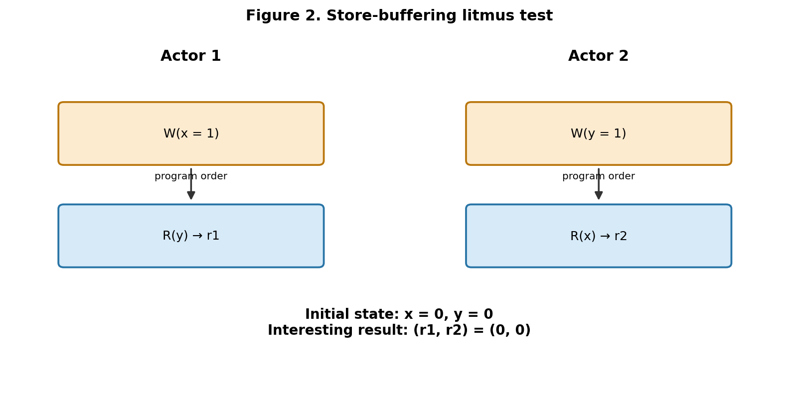
Initial state: x = 0 and y = 0. Two actors each write one variable and then read the other. The result is the tuple (r1, r2).
Actor 1: Actor 2:
x = 1 y = 1
r1 = y r2 = x
Result (r1,r2) | Meaning | Plain int fields | volatile int fields
0,0 | Neither actor sees the other write | ALLOWED by JMM | FORBIDDEN by JMM
0,1 | Actor 1 reads 0; Actor 2 reads 1 | Allowed | Allowed
1,0 | Actor 1 reads 1; Actor 2 reads 0 | Allowed | Allowed
1,1 | Both read 1 | Allowed | Allowed
Why plain (0,0) is allowed: there is no synchronizes-with relationship ordering either actor's write before the other actor's read. Each read can observe the initial value under a legal execution.
Why volatile (0,0) is forbidden: volatile reads/writes participate in synchronization order, consistent with each thread's program order. If both reads saw the initial zero, each read would have to precede the other actor's volatile write in synchronization order, while program order places each write before its own read. Those constraints form a cycle, which is impossible for a total synchronization order.

D. Litmus test 2 — Message passing / publication
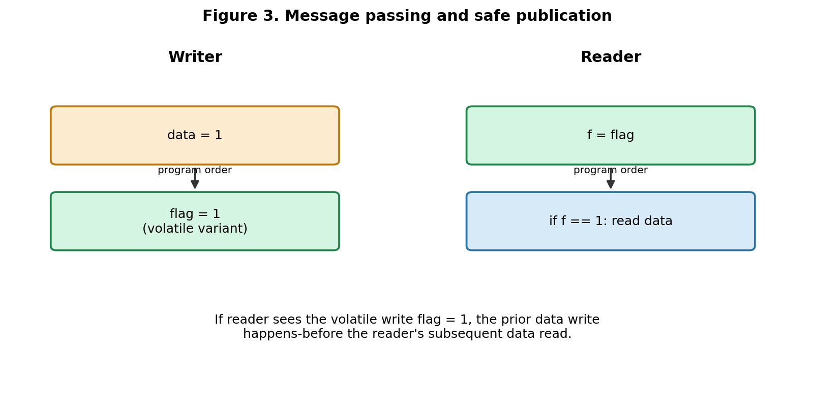
Initial state: data = 0 and flag = 0. Writer stores data then flag. Reader reads flag and, if it sees 1, reads data.
Writer: Reader:
data = 1 f = flag
flag = 1 if (f == 1) r2 = data
Result (flagRead,dataRead) | Plain flag + data | volatile flag + plain data
0,-1 | Allowed | Allowed
1,1 | Allowed | Allowed
1,0 | Allowed under data race | FORBIDDEN by JMM
In the volatile version, the volatile write flag=1 synchronizes-with a reader volatile read that observes it. The earlier data=1 write happens-before the subsequent data read, so the initial data=0 cannot be returned in this test. A plain flag creates no such publication edge.

E. Java implementation: JCStress tests
JCStress is OpenJDK's experimental harness for concurrency outcomes in JVMs, class libraries, and hardware. It runs actors repeatedly and records observed states. It is a better fit than a single hand-written loop, but it remains an empirical harness: not observing a permitted outcome does not prove it impossible.
Four complete test classes are included in the project ZIP under experiments/jcstress-store-buffering/src/main/java/ordering/.
File / class | Purpose | Key outcome annotation
PlainStoreBuffering.java | Store buffering with ordinary ints | 0,0 ACCEPTABLE_INTERESTING
VolatileStoreBuffering.java | Store buffering with volatile ints | 0,0 FORBIDDEN
PlainMessagePassing.java | Plain-field publication | 1,0 ACCEPTABLE_INTERESTING
VolatileMessagePassing.java | Volatile flag publication | 1,0 FORBIDDEN

Build and run
cd experiments/jcstress-store-buffering
mvn clean package
java -jar target/module07-jcstress.jar -h
java -jar target/module07-jcstress.jar -m quick
java -jar target/module07-jcstress.jar
These commands are provided, not verified in this authoring environment. If the shaded JAR name differs, inspect the target directory and use the actual generated artifact. A successful build is not the same as a full experiment.

F. Experiment design and reproducibility
Design item | Specification
Hypotheses | Plain store buffering may show (0,0); volatile store buffering must not. Plain message passing may show (1,0); volatile-flag message passing must not.
Independent variables | Litmus family; plain versus volatile field semantics; test mode and runtime configuration (recorded, not silently varied).
Dependent variables | Observed result tuples, JCStress classifications and counts.
Controls | Same host, JDK vendor/version, OS, JCStress version, JVM options, and equivalent actor structure for comparisons.
Procedure | Build; list/discover tests; quick smoke test; full run; archive raw output; repeat campaign if permitted outcome is not seen.
Raw evidence | Full console/HTML output, exact command, JDK/Maven versions, CPU model/architecture, OS, JVM arguments, run mode and timestamp.
Analysis | Compare observed tuples with the JMM outcome tables; investigate any reported forbidden outcome rather than redefining the specification.
Limitations | Finite runs; scheduling/JIT dependence; host-specific observation; no causal proof of a specific instruction or microarchitectural mechanism.

Environment commands
java -version
mvn -version
# Linux
uname -a
lscpu
# Windows PowerShell
Get-ComputerInfo | Select-Object WindowsProductName,OsVersion,CsProcessors

Results — PENDING LOCAL EXECUTION
Test | Key outcome | JMM status | Observed count | Evidence status
Plain store buffering | (0,0) | Allowed | PENDING | NOT RUN
Volatile store buffering | (0,0) | Forbidden | PENDING | NOT RUN
Plain message passing | (1,0) | Allowed | PENDING | NOT RUN
Volatile-flag message passing | (1,0) | Forbidden | PENDING | NOT RUN
Never fill counts from expectation or fabricated examples. A permitted result can be rare or absent in a finite run. An observed forbidden result demands investigation of the test, classification, runtime, or a possible implementation defect.

G. Evidence levels: specification, JVM, ISA, observation
Evidence level | What it can establish | What it cannot establish alone
JLS/JMM guarantee | Whether a Java outcome is allowed or forbidden by Java semantics | Which physical instruction or CPU event caused an outcome
JVM/JIT observation | Bytecode, compiled method, optimization decisions for one exact JDK/configuration | Universal behavior across JDKs, flags, architectures
ISA manual | Architectural ordering rules for a named processor architecture and instruction set | Which instructions the JVM actually emitted in the run
JCStress result | Observed outcomes under the recorded environment and test campaign | Proof that an unobserved outcome is impossible
Timing result | Performance difference in the tested workload/setup | Proof of cache misses, MESI transitions, fences or store-buffer behavior

H. Optional deeper investigation: bytecode, JIT assembly, CPU
- Record the exact JDK build and JVM arguments before investigating generated code.
- Use javap -c -v to inspect bytecode. Bytecode is not necessarily the final machine code executed after JIT compilation.
- For HotSpot, compilation logs and diagnostic assembly options may help, but flags and assembly support vary by JDK build and may require a disassembler plugin.
- Identify the exact compiled methods and compilation tier; do not confuse interpreter execution with warmed-up compiled execution.
- Compare the emitted instructions with the relevant CPU vendor manual for the tested ISA and processor family.
- For physical events, use validated performance-monitoring events/profilers, recording CPU model, event definitions, tool version, permissions and raw output.
Even assembly inspection is evidence about one implementation/configuration. A specific causal claim about a store buffer or fence needs a reasoned mapping from source to emitted instructions and architecture documentation; timing alone is insufficient.

I. Common misconceptions
- “Source code is sequential, so every thread sees stores in that order.” False: source program order does not alone create inter-thread publication guarantees.
- “The CPU reordered it, therefore the JMM allows it.” False: Java semantics constrain the legal observable result even if a hardware model would allow more behaviors.
- “I did not observe (0,0), so it is impossible.” False: non-observation in finite testing proves nothing about impossibility.
- “volatile makes increment atomic.” False: volatile does not turn compound read-modify-write operations such as x++ into atomic operations.
- “x86 results define Java behavior.” False: Java semantics are not inferred from one architecture's behavior.
- “Coherence solves ordering.” False: coherence and memory ordering are related but distinct concerns.

J. Likely reviewer questions and answers
What is the difference between source order and memory-observation order?
Source order is a language-level order within a thread; memory-observation order describes what other threads can observe under the memory model and ISA. They are not identical.
Why can plain store buffering return (0,0)?
The plain accesses are data-racy and have no synchronizes-with edges; each read may see the initial value in a legal JMM execution.
Why is volatile store buffering (0,0) forbidden?
The required synchronization-order constraints would form a cycle, which a total synchronization order cannot contain.
Why is volatile message passing safe here?
The volatile flag write synchronizes-with a read that observes it, creating happens-before from the prior data write to the subsequent data read.
Can JCStress prove an outcome impossible?
It can discover outcomes and test implementation behavior, but finite non-observation cannot prove impossibility. The JMM specification determines the normative status.
Does the (0,0) tuple prove a physical store-buffer event?
No. It is consistent with possible mechanisms, but a tuple alone cannot isolate compiler/JIT and CPU causes.
Why not add a latch each iteration?
Extra synchronization can alter the ordering being tested. A concurrency outcome harness is designed to minimize and control test structure.
Is this a benchmark?
No. It measures outcome frequencies/classifications, not throughput or latency. Use JMH for performance studies.

K. Contribution and KT checklist
- ☐ Read the Project Contract and relevant handoffs; verify scope and terminology.
- ☐ Explain each actor operation and each result tuple without notes.
- ☐ Build with the team's JDK/Maven and preserve exact output.
- ☐ Run quick smoke mode and a full JCStress campaign.
- ☐ Record environment and raw outcomes; keep unedited outputs.
- ☐ Check outcomes against JMM tables; investigate forbidden outcomes.
- ☐ Inspect bytecode/assembly only when exact runtime and tools are available.
- ☐ Present limitations and distinguish specification guarantees from measured observations.

L. Handoff packet — Vanshraj to Prachi
Shared objective: one integrated engineering project on hardware concurrency, memory models and lock-free design. Preserve the existing hardware-concurrency-lab structure, Java 17 target and Maven conventions. This module is isolated as a JCStress subproject; it does not modify the main POM.
Files: four Java tests under experiments/jcstress-store-buffering/src/main/java/ordering/; report; references; m07_environment-template.md; m07_outcomes-template.csv. Public classes are test states, not production APIs.
Key outcomes to carry forward: plain store buffering (0,0) is JMM-allowed; volatile store buffering (0,0) is forbidden; plain message passing (1,0) is allowed under a data race; volatile-flag message passing (1,0) is forbidden.
Avoid repeating detailed cache hierarchy, MESI/MOESI diagrams and false-sharing material. Prachi should connect these exact outcomes to formal JMM happens-before and memory-ordering rules.
Dependencies: Java 17+, Maven, JCStress dependency download access. Verification status: source and report prepared; build, test discovery, quick/full runs, raw result collection and assembly inspection NOT RUN.
Outstanding inputs for Prachi: actual JCStress output, environment metadata, and any verified bytecode/assembly excerpts. Do not infer results before the run.

M. Source-backed references
- Java Language Specification, Java SE 17, Oracle — §17.4 Memory Model; §17.4.5 Happens-before Order; §17.4.7 Allowed Executions. https://docs.oracle.com/javase/specs/jls/se17/html/jls-17.html
- Java Language Specification, Java SE 17, Oracle — §8.3.1.4 volatile Fields. https://docs.oracle.com/javase/specs/jls/se17/html/jls-8.html#jls-8.3.1.4
- Java Virtual Machine Specification, Java SE 17, Oracle — JVM and bytecode model; use alongside JLS for implementation-level questions. https://docs.oracle.com/javase/specs/jvms/se17/html/
- OpenJDK JCStress — Experimental harness purpose, build/run guidance and interpretation cautions. https://github.com/openjdk/jcstress
- Intel 64 and IA-32 Architectures Software Developer Manuals — Architecture-specific instruction and memory-ordering claims; consult the exact volume/section for the tested CPU. https://www.intel.com/content/www/us/en/developer/articles/technical/intel-sdm.html
- Arm Architecture Reference Manual — Architecture-specific ordering claims for the relevant Arm architecture revision. https://developer.arm.com/documentation/
Citation discipline: JLS sections support language guarantees; JCStress documentation supports harness usage and limitations; vendor manuals support only architecture-specific claims. Do not claim a specific CPU mechanism without matching implementation evidence.

N. Final self-audit
Requirement | Status | Evidence / next action
Only assigned Module 07 | PASS | Other modules not regenerated
Program order/JIT/CPU/observable order distinguished | COVERED | Sections B and G
Two litmus tests and outcomes | PREPARED | Sections C and D; Java test classes included
Complete runnable test source and exact commands | PREPARED | Isolated Maven subproject in ZIP
Source-backed references | PREPARED | Section M with precise sections/URLs
No fabricated measurements | PASS | All execution fields PENDING / NOT RUN
Handoff to Prachi | PREPARED | Section L
Build, full run, KT review | PENDING | Team must execute and record evidence
Final status: this is an engineering study and reproducibility package, not a claim that experiments have already succeeded. Update evidence status only after real execution and review.

